KITH AND KIN INTERNATIONAL COLLEGE

*7/11 Kaoli Olusanya Street, Owode Ibeshe, Ikorodu, Lagos State.*

THIRD TERM EXAMINATION 2024/2025 ACADEMIC SESSION

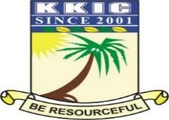

|  |  |  |  |  |  |
| --- | --- | --- | --- | --- | --- |
| **NAME** |  | | | | |
| **SUBJECT** | **PHYSICAL & HEALTH EDUCATION** | **CLASS** | **JSS 2** | **DURATION** | **1 1/2** hours |

**SECTION A, OBJECTIVES:**

**INSTRUCTION:** Answer all questions

1. Look at this picture and tell me what their trying to do?

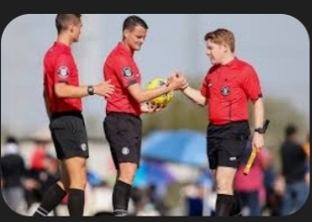

A. Coach in action

B. The Player is combating the referee

C. Official enforcing rules during a game

D. Spectator interrupting the officials

2. Which of these is an example of a central official in football?

A. Linesman

B. Goalkeeper

C. Center referee

D. Captain

3. Endurance training mainly improves which body system?

A. Nervous system

B. Skeletal system

C. Digestive system

D. Cardiovascular system

4. Which of the following is an endurance workout?

A. Push-up

B. Sprinting

C. Long-distance running

D. Weightlifting

5. Recreational activities are usually done for:

A. Stress

B. Punishment

C. Enjoyment

D. Competition only

6. With this picture showing bellow, point on the kind of sports they are performing

A. Indoor recreation

B. Martial art recreation

C. Adaptive sports

D. Professional aquatic sports

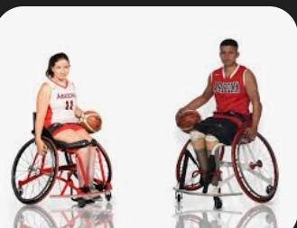

7. Which of these is an adaptive sport?

A. Chess

B. Wheelchair basketball

C. Archery

D. Baseball

8. How many bones are in the adult human skeleton?

A. 180

B. 206

C. 209

D. 300

9. Which bone protects the brain?

A. Femur

B. Humerus

C. Skull

D. Tibia

10. Which of these is not a duty of a linesman?

A. Flagging offside

B. Signaling throw-ins

C. Awarding red cards

D. Assisting the referee

11. What is the primary benefit of endurance training?

A. Increased strength

B. Improved flexibility

C. Enhanced stamina

D. Better eyesight

12. Which is an example of anaerobic endurance?

A. Jogging

B. Yoga

C. Sprinting

D. Cycling

13. Which is a recreational sport?

A. Tennis

B. Boxing

C. Wrestling

D. Karate

14. Which of these is done primarily for leisure?

A. Football league match

B. Inter-school competition

C. Family picnic volleyball

D. Olympic tryouts

15. Which of these is considered a leisure activity?

A. Gymnastics

B. Handball match

C. Hiking

D. Basketball league

16. Adaptive sports are designed for:

A. The elderly

B. Children

C. People with disabilities

D. Professional athletes

17. Which of the following is an adaptive sport?

A. High jump

B. Taekwondo

C. Blind football

D. Cricket

18. What makes sports “adaptive”?

A. New rules

B. Inclusion of professionals

C. Modified for people with disabilities

D. Played indoors only

19. The longest bone in the body is the:

A. Tibia

B. Fibula

C. Femur

D. Humerus

20. Flexion refers to:

A. Straightening a joint

B. Twisting a joint

C. Bending a joint

D. Relaxing a joint

21. Rotation movement is best shown in the

A. Neck

B. Knee

C. Elbow

D. Ankle

22. Which of the following is an example of extension?

A. Straightening the elbow

B. Bending the knee

C. Twisting the arm

D. Flexing the wrist

23. Swimming improves

A. Cardiovascular fitness

B. Memory

C. Arm strength only

D. Neck movement

24. Which of these is a basic swimming technique?

A. Floating

B. Dribbling

C. Dunking

D. Passing

25. Which swimming stroke resembles a frog’s kick?

A. Breaststroke

B. Butterfly

C. Backstroke

D. Crawl

26. Football is a:

A. Dual sport

B. Solo sport

C. Combat sport

D. Team sport

27. Strategy in team sports helps to:

A. Waste time

B. Distract fans

C. Avoid playing

D. Win games

28. Which activity improves cardiovascular endurance?

A. Playing chess

B. Long jump

C. Curl-ups

D. Running

29. Look at this picture carefully,what do you they are doing?

A. Calisthenics

B. Wrestling

C. Sprinting

D. warm-up exercise

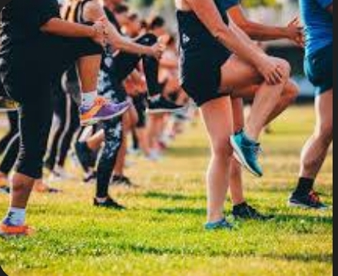

29. A good

30. Common injury in sports includes:

A. Cold

B. Fever

C. Malaria

D. Sprain

31. Preventing injuries can be achieved by

A. Using protective gear

B. Playing without rest

C. Avoiding warm-ups

D. Not practicing

32. Which of these is a gymnastic skill?

A. Cartwheel

B. Passing

C. Batting

D. Dribbling

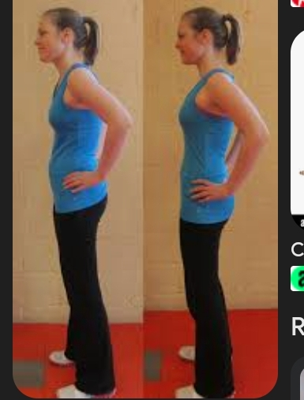

In relation with the picture above, what do you think they are trying to correct?

1. Good and bad posture
2. Postural habit
3. Feet postural defects
4. Kyphosis

33. What is the correct body part for a handstand?

34. Gymnastics improves:

A. Flexibility and balance

B. Vocabulary

C. Math skills

D. Memory

35. Which of the following is not a benefit of PE?

A. Encourages laziness

B. Promotes fitness

C. Enhances teamwork

D. Builds discipline

36. Physical Education helps in the development of:

A. Cognitive abilities

B. Spiritual awareness

C. Political views

D. Laziness

37. PE contributes to national development by

A. Enhancing sports participation

B. Increasing corruption

C. Reducing school fees

D. Promoting fashion

38. Which of these is not a function of sports officials?

A. Enforcing rules

B. Keeping scores

C. Playing for the team

D. Making decisions

39. Which of these is an official in basketball?

A. Goalkeeper

B. Umpire

C. Quarterback

D. Referee

40. Leisure activities help to:

A. Increase fatigue

B. Cause sickness

C. Waste time

D. Reduce stress

41. Which of these movements is a rotation?

A. Straightening the knee

B. Turning the head side to side

C. Bending the elbow

D. Stretching the fingers

42. The shoulder joint allows for what type of movement?

A. Gliding

B. Rotation

C. Inversion

D. Eversion

43. Volleyball is a sport that involves:

A. Solo play

B. Two teams

C. No ball

D. No rules

44. A sprain affects the:

A. Heart

B. Ligaments

C. Blood

D. Muscles only

45. Which part of the body performs the breaststroke?

A. Arms only

B. Full body

C. Legs only

D. Neck only

46. Injury prevention in sports includes:

A. Playing without warm-ups

B. Wearing correct gear

C. Ignoring pain

D. Over-training

47. Which is an example of teamwork in sports?

A. Running alone

B. Passing in football

C. Serving in volleyball

D. Training without a coach

48. Which joint allows for movement in all directions?

A. Hinge joint

B. Ball and socket joint

C. Pivot joint

D. Gliding joint

49. Muscles that work in pairs are called

A. Ball and socket joint

B. Antagonistic muscles

C. Rotating muscles

D. Group muscles

50. An assistant referee uses a:

A. Whistle

B. Flag

C. Red card

D. Baton

SECTION B, THEORY:

INSTRUCTION: Answer three questions from the following but number one (1) is made compulsory

1A. Define sports (1 Mark)

1. Mention two types of sports with one example for each. (2 Marks)
2. State two benefits of sports. (1 Mark)
3. What is the meaning of recreational sport? (1 Mark)
4. Mention two examples of leisure activities. (2 Marks)
5. What is adaptive sports? (1 Mark) J. List two examples of adaptive sports. (2 Marks)

2A. Define recreation and include three things that it meant for (4 marks)

1. List six examples of recreational activities. (3 marks)
2. What is dance and mention two things that it often goes with. (3 marks)

3A. What is a dislocation and state two joints displacement (5 marks)

1. What does R.I.C.E stand for in injury treatment? (3 marks)
2. State two ways to prevent sports injuries. (2marks)

4A. What are two good differences between table tennis and tennis (2 marks)

1. Mention two pieces of equipment used in table tennis (2 marks)
2. What is the length of standard table tennis table? (2 marks)
3. “**Deuce**” means ? (2 marks)
4. What is a serve in table tennis? (2 marks)

5A. What are the key components of coordination ? (2 marks)

B. Define coordination and give two examples of coordination activities (2marks)

C.Discuss the importance of balance in physical education? (2 marks)

D. Why is coordination important in sports? (2 marks)

E. In which way can we improve coordination (2 marks)

6A. What is martial arts? (2 marks)

1. List two types of martial arts (2 marks)
2. What is a “dojo” in martial arts? (2 marks)
3. Who is a “sensei” in martial arts? (2 marks)
4. What is the meaning of “kata” in martial arts? (2 marks)